This document contains detailed information related to bugs and also 1 proposed change request at the end.

**Bug ID: 1**

**Summary:**

Unable to register user with “7” characters long password.

**Steps To Reproduce:**

1. Navigate to [https://buggy.justtestit.org](https://buggy.justtestit.org/)
2. Click on Register button
3. Populate field details as below:

* Login: [test@test.com](mailto:test@test.com)
* First Name: John
* Last Name: Martin
* Password: 12
* Confirm Password: 12

1. Click on Register link at the bottom
2. Verify error message “InvalidParameter: 1 validation error(s) found. - minimum field size of 6, SignUpInput.Password.” is displayed which indicates that minimum length of password should be of 6 characters
3. Change password details so that it is of 7 characters long (i.e., more than 6 characters) as below:

* Password: Aa!1234
* Confirm Password: Aa!1234

1. Click on Register link at the bottom

**Expected Result:** User should have been registered successfully.

**Actual Result:** Validation message as “InvalidPasswordException: Password did not conform with policy: Password not long enough” is displayed indicating password is not long enough although as per validation message obtained in step 5 above, password should have been of 6 or more characters.

**Screenshot/Screen recordings:**

After Step 4 –

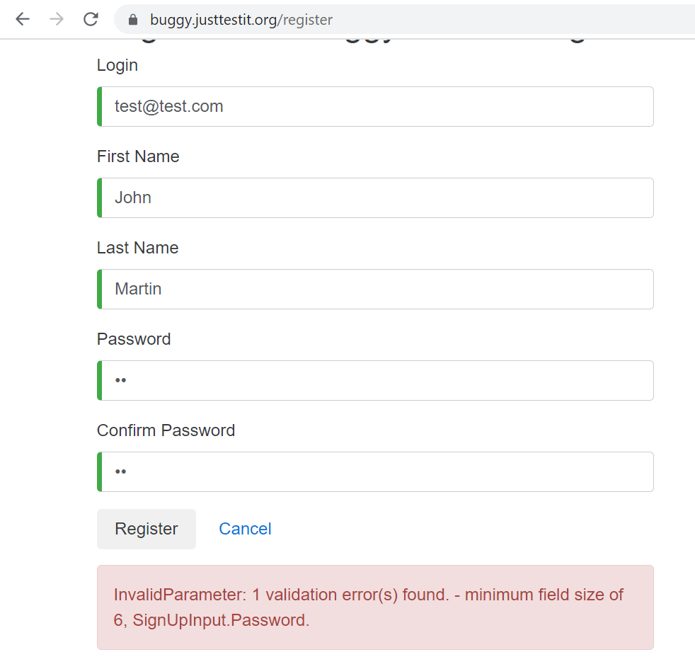

After Step 7 –

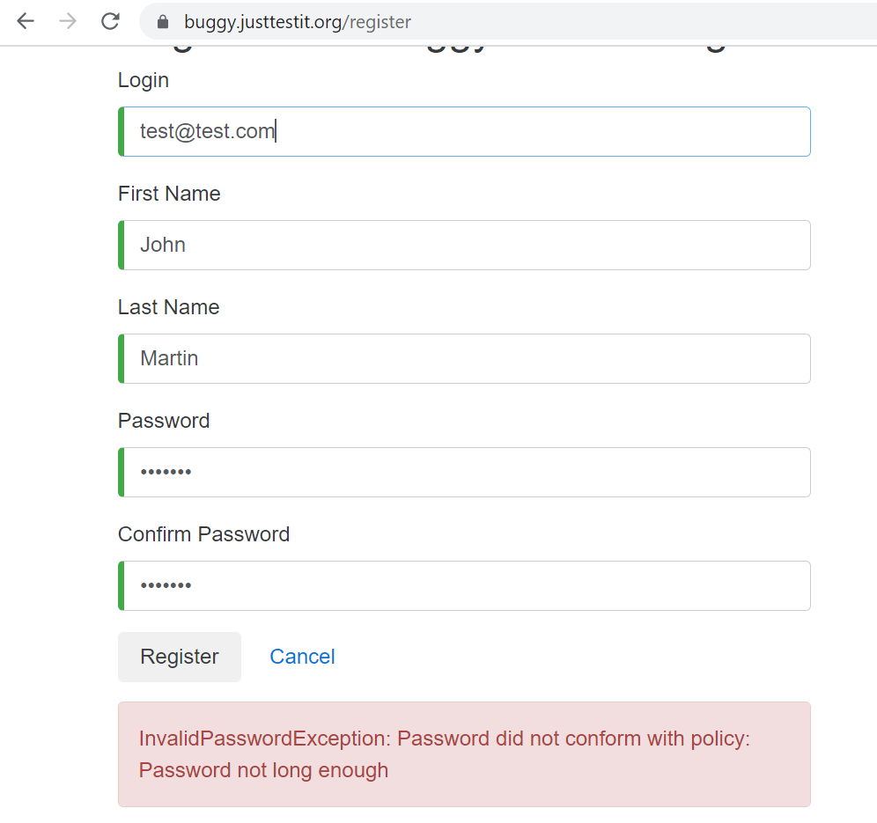

**Bug ID: 2**

**Summary:**

Broken link on clicking “Buggy Rating” logo.

**Steps To Reproduce:**

1. Navigate to [https://buggy.justtestit.org](https://buggy.justtestit.org/)
2. Click on image displayed under “Popular Make” section
3. Hover over on “Buggy Rating” logo and verify the navigation “url” displayed at the bottom left corner
4. Now click on “Buggy Rating” logo

**Expected Result:** User should have been navigated to homepage i.e., [https://buggy.justtestit.org](https://buggy.justtestit.org/) successfully.

**Actual Result:** After Step 3 above, broken link as <https://buggy.justtestit.org/broken> was displayed on bottom left corner and on clicking on logo nothing happened.

**Screenshot/Screen recordings:**

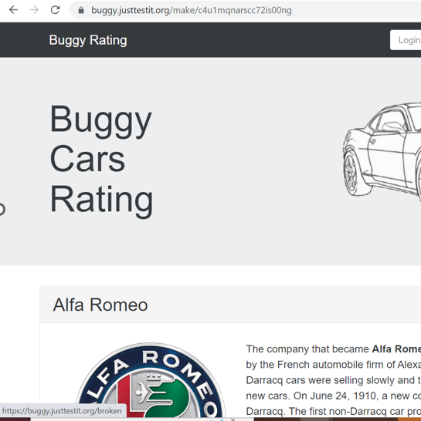

**Bug ID: 3**

**Summary:**

In overall rating page, pagination is not maintained properly and also user is able to enter decimal values in page number

**Steps To Reproduce:**

1. Navigate to [https://buggy.justtestit.org](https://buggy.justtestit.org/)
2. Login with valid credentials by entering username, password and clicking on Login button
3. Click on image displayed under “Overall Rating” section
4. Scroll down to the bottom of the page and verify the pagination which is displayed as “page 1 of 5” and page “1” is selected
5. Keep clicking on next page icon link until user is navigated to 6th page and now verify the pagination
6. Now try to update this page “6” by entering “6.1” in page count box and click on enter button and verify the pagination

**Expected Result:**

1. Pagination message should have been correctly displayed and user should only be able to navigate till last page such that “page (n+1) of n” should never be a possible case
2. User should be restricted to enter decimal values in page count box i.e., “6.1” in page count box should never be a possible case

**Actual Result:**

1. User was able to navigate to infinite pages and pagination message was incorrectly displayed as “page 6 of 5”, “page 9999 of 5” etc.
2. User was able to enter decimal values manually with no restriction in page count box like “6.1”, “9.999” etc. and after entering value like “6.1” then pagination message was displayed as “page 6.1 of 5” and it displayed records from page 1. Also, if user clicks on lower page link, then the value changed from 6.1 to 5.1 to 4.1 and sometimes to 3.0999999999 and in this fashion it went down until “1”. (Note: Please find attached PPT containing video recording)

**Screenshot/Screen recordings:**

After Step 5 –

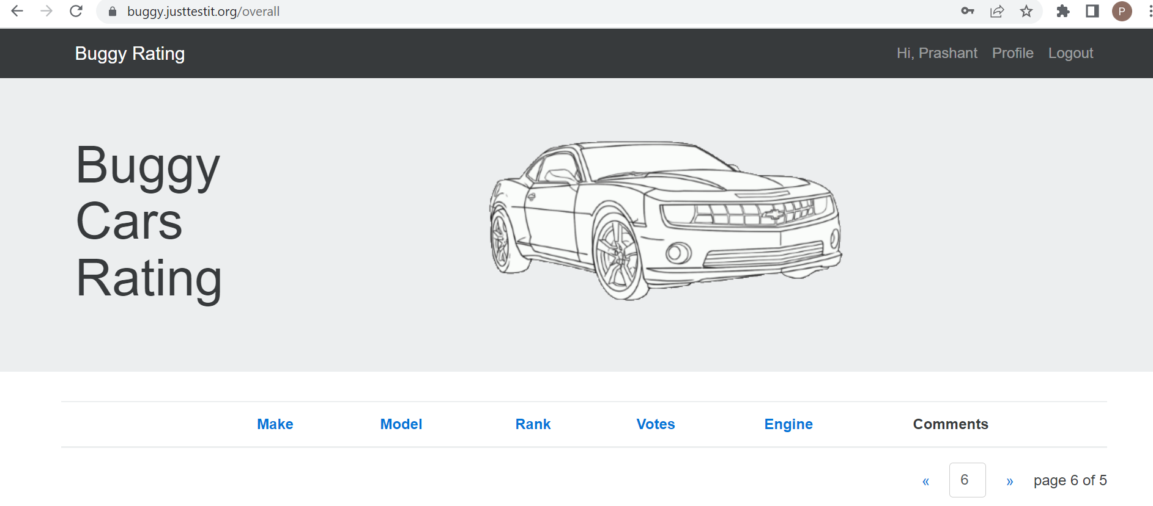

After step 6 –

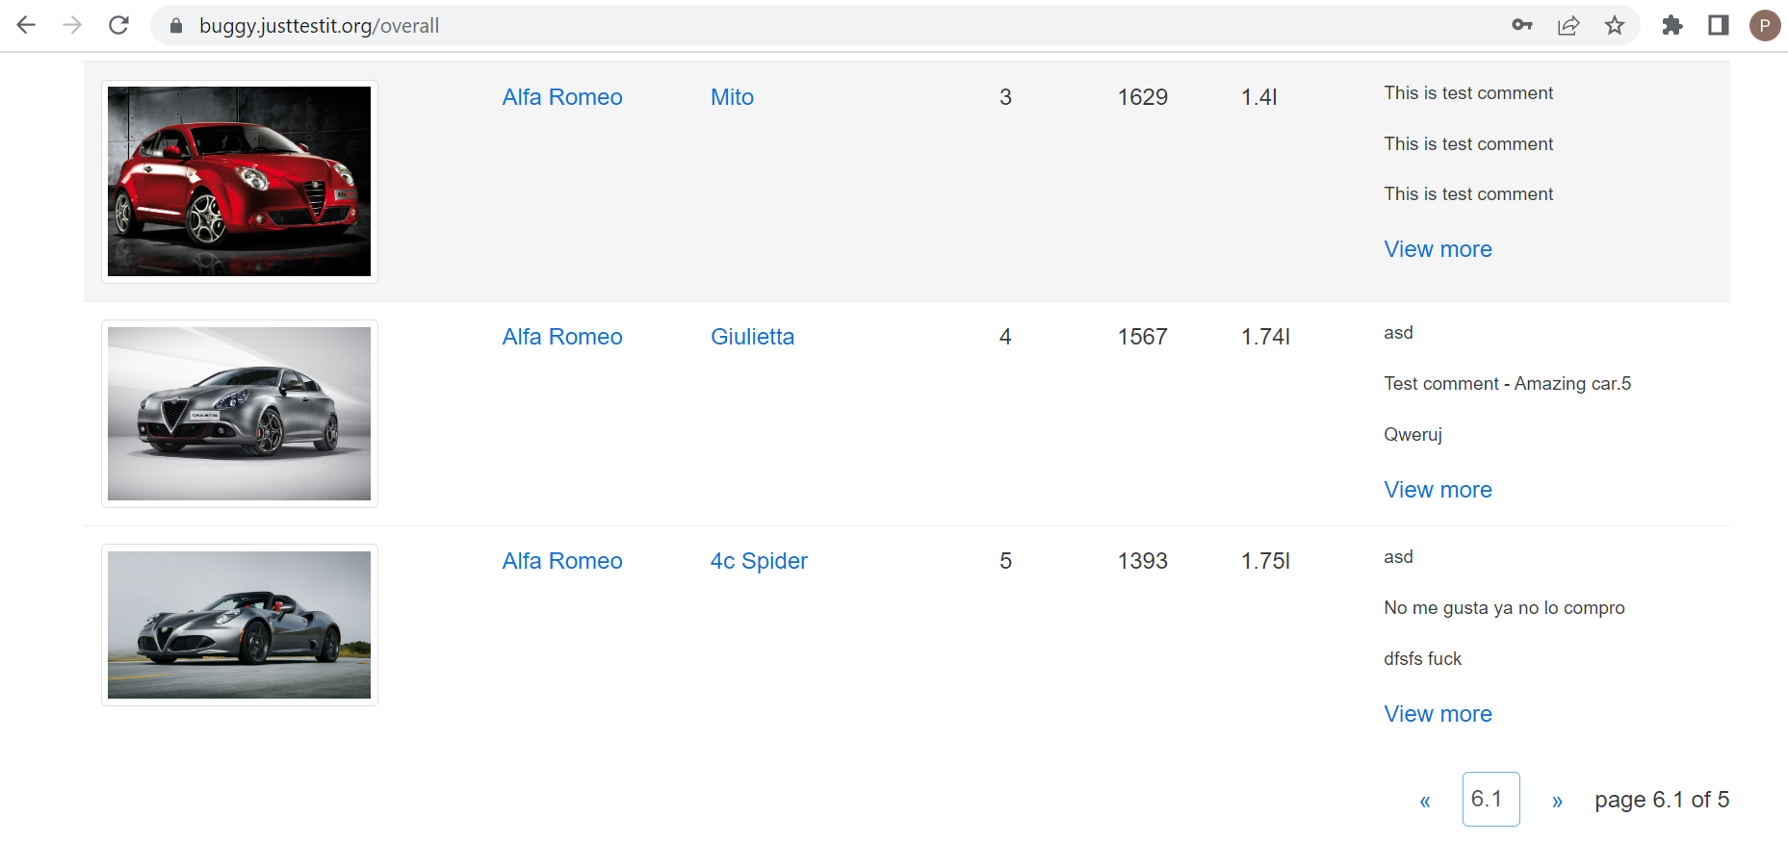

Screen recording –



**Change Request Proposal: 1**

**Summary:** The site [https://buggy.justtestit.org](https://buggy.justtestit.org/) does not have any way currently for user to retrieve its password as there is no “Forgot password” flow in the current website. So, there is no way to recover the account in case user forgets his/her password.

**Proposed change:** Introduce “Forgot password” scenario so that in case user forgets his/her password then it can be recovered.